Let's discuss ways to improve our use of limited resources to remove barriers to learning. Some of the free services we provide to our students. Safety services for escorting individuals. Tutoring services to provide guidance in the unknown. Career counseling to guide in making the optimal choice in careers. We will be discussing a data set that contains the challenges of life as a student. With additional understanding of the challenges of life, we can better optimize the budget of the resources for students. We have discovered the underlying patterns of the challenges that face a student. Let's explore the needs of our students.

Our institutional service to the community is to transform youth into adults. Our value comes from maximizing the number of people who can be transformed as well as the quality of transformation. It’s more than simply providing goals to overcome. Creating environments for successful growth has many facets to utilize. We cannot rely solely on traditional education. It's our duty to successfully develop new processes to assist in education. The activities that facilitate learning are more than just lectures. We can discuss ways of expanding our services to successfully increase the number of students who succeed. It's our mission to make all students walk these halls a successful alumni also able to become a functioning adult. Our data shows that 1027 of 1100 students surveyed have at least one high score that has a strong negative relationship with academic performance and of those who have a very high score in one is 657. Let's take a moment to consider the great challenges we face in improving the students' lives. Yet the human spirit is strong for having one score not significantly affect students' failure.

The ritual of learning skills to be an asset to one of the many communities can be distributed by many distractions, lack of support, or needs of life. As these tools evolve to capture the attention of the student, so must we evolve to educate on life management. Our data of the students' life was found on the website of kaggle which is a repository of data to be used in the learning of data science. The first category measures the psychological factors. The data divided these into depression, having a mental health history, anxiety level and self esteem. The second category is ones of self care. The data divides these into headaches, blood pressure, sleep quality, breathing problems. Third category is the environment. The data divides these into noise level, living conditions, safety, and basic needs. The fourth category are those of academics. The data divides these into academic performance, study load, teacher student relationship, future career concerns. The fifth category is social life. The data divide these into bullying, social support, peer pressure, extracurricular activities, academic performance. Lastly, overall stress of the student which is the goal of the data to predict. I think it's more insightful to determine conditions where average academic performance changes to show where to put our resources.

The First Hypothesis is called critical interference. An individual is under so many distractions from mental health that they cannot make the necessary time in their life to conduct the ritual of learning. A student under these conditions is unlikely to perform well. What is the average of these students?

Let's use a story for example: A student with high anxiety, and having a mental health history having to spend a lot of time dealing with the issue rather than studying. The person might have therapy sessions, avoiding behaviors of studying that makes them more likely to waste time on tick tock.

The averages are as we expected low scores of success. We filtered the data to include only the high scores of two variables then took the average academic performance. Anxiety and Depression have a score of 1.66. Self Esteem and Anxiety have a score 1.62. Self esteem and mental health history have a score of null. We don't have anyone with those scores in the data. Anxiety and mental health history have a score of 1.54. Depression and mental health have an average score 1.61. All these scores are below 2 which the institution has a possible beneficial relationship to build systems to retain these failing students.

The second hypothesis is called mental health separation. Having mental health history will increase the impact on the reduction of average grades for every type of factor. We take one factor's average grades and split the data into two groups of having a history or not to determine the effect on average grades. First let's show you a data example of just average grades by depression. 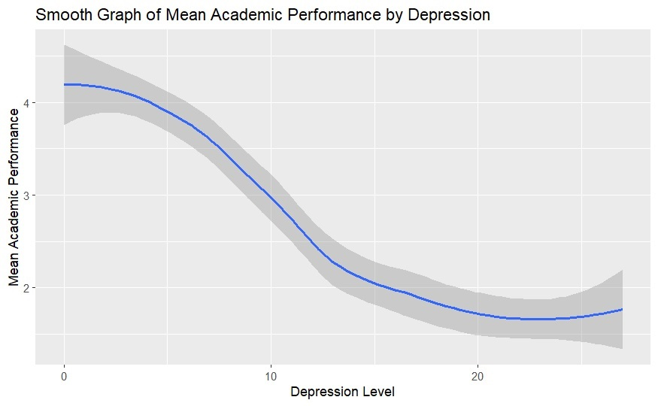

As expected the group with higher levels of depression has lower grades on average than those who do not. Now let's introduce the depression and mental health history graph. 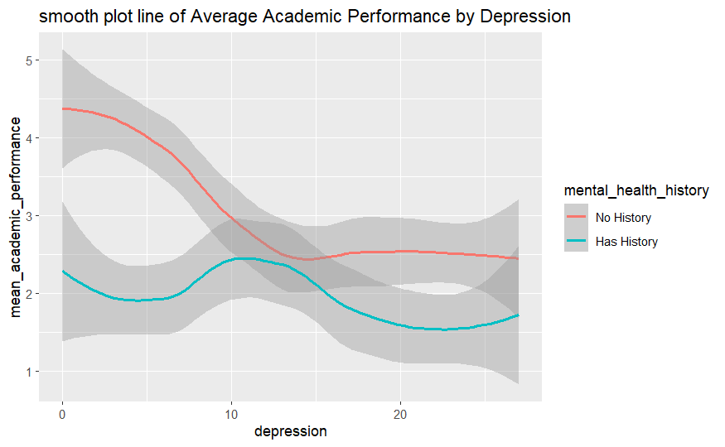

We can notice the slight increase in the average grades of those who have no history across the spectrum of depression. In the upper range 20 to 30 we start to see the average drop below two which is sufficient for a student to start failing at the university. Mental health seperation is about all possible combinations of the factors that interfere with grades. The depression effect on the brain is all the worrying exhausted the students. It zaps the student of the will to continue the struggle to learn. Lets see for anxiety with the history split again to show the similar pattern

emerges.

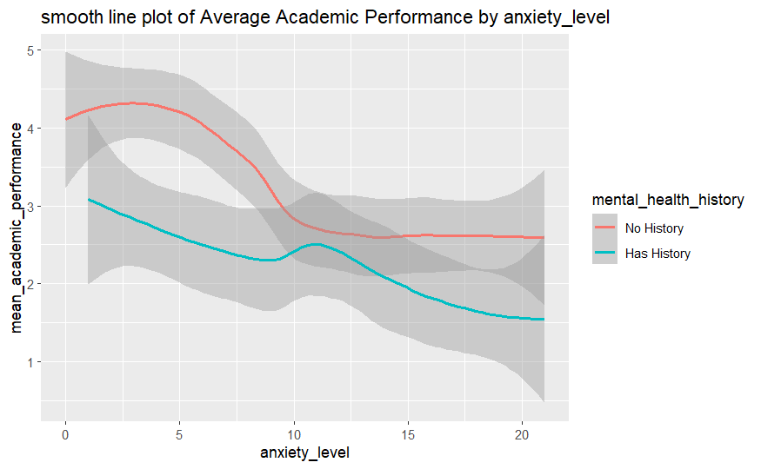

Anxiety the flight response interferes with learning by preventing a person from retaining information. The anxiety responses produce a distraction for the student. It also affects short term memories. The last part of the problem of anxiety is avoiding the tasks at hand i.e wasted time that could be dedicated to learning. It's no surprise that we see the same trends for anxiety and depression with the same decrease in mental health history.

Let's show basic needs which are a measure of the students wealth or time they have to spend working. We see the similar pattern of decreasing the grades of the students who share the attribute of mental health history. 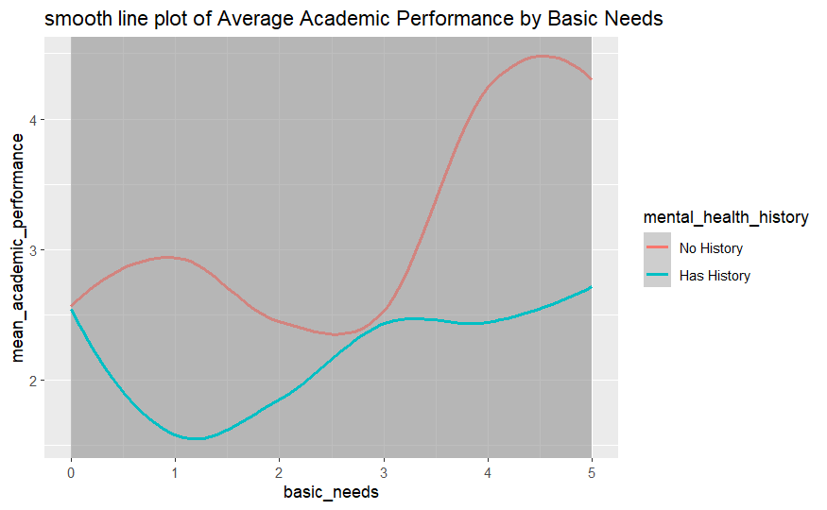

We have the same trend lines and the save averages emerge from the graph. Remember to pay attention to the lower end of basic needs due to these are the conditions that interfere with learning.

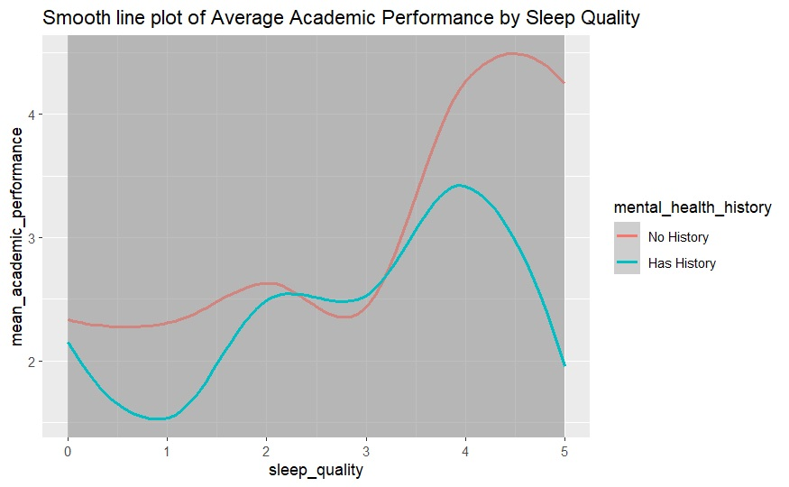

This graph is a bit unusual. Does serve as a counterexample to the theory of mental health separation. What does the variable sleep quality measure? Why having a 4 has better grades than a 5. Well that can be explained that the student is sleeping too much which time is not dedicated to learning? Why in the mid range do they overlap? The separation does not exist in this range. Even though it is a strong pattern for most data it is not always consistent.

Here is another counter example to mental health separation.

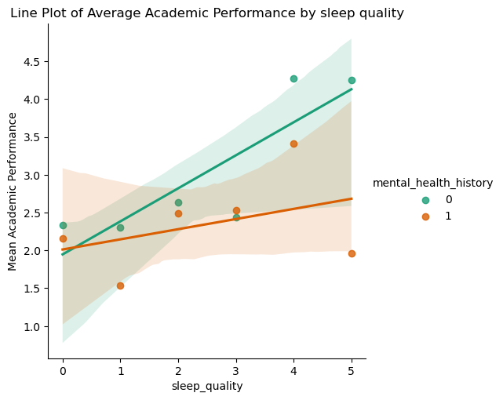

The graphs overlap too much to prove that having a mental health history lower grades when subjected to a factor that interferes with the routine of studying. However, We have a strong pattern gained from the data that indicates possible action forward.

In the range that starts to have lower average grades, what is the most common occurrence in the data. I checked all the factors: these are the most common living conditions, basic needs and safety have the highest count in the data.

What variable has the strongest correlation with grades? Correlation affects the strength in which you change one variable the other also changes. I calculated all the variables with academic performance to find that it is stress which is the greatest correlation.

If a student has a score that negativity affects grades, do we still see high performing students? 654 students of the 1100 students have at least one very high score. It shows us the difficult challenges in life to produce circumstances for all students that allow them to succeed free from the many difficulties of life.

How well is the institution doing to produce high academic performance? The data set contains 1100 students so we have 370 students with scores 4 or 5.

In conclusion, life is full of difficulties and our mission is to make every student successful. The process comes from the reduction of challenges they face. Reducing the separation of these factors will improve our grades and the chance that students will succeed. Watching out for concentrations of lifes challenges in the students can be incorporated into our academic routines of education. Helping people live life better is part of achieving that goal.

The recommended course of action is to add CBT therapy to part of the core curriculum. Helping students understand the mental habits and the impact of their life. According to the therapy, the habits of the mind make the emotional states we are in. CBT therapy teaches us that by simply addressing the habits of the mind we can break their power over our actions. Due to lack of mental health education and the sigma of the practice, we have much to gain in improving the students ability to fight habits of feeling of worthlessness, feeling of inability, ect. Now we understand critical inference, mental health separation we can now address the problem improving our ability to keep students and the weakness in the curriculum.